2022 Belleville Don Gerry Open

Field Designation
Zwicks Centennial Park
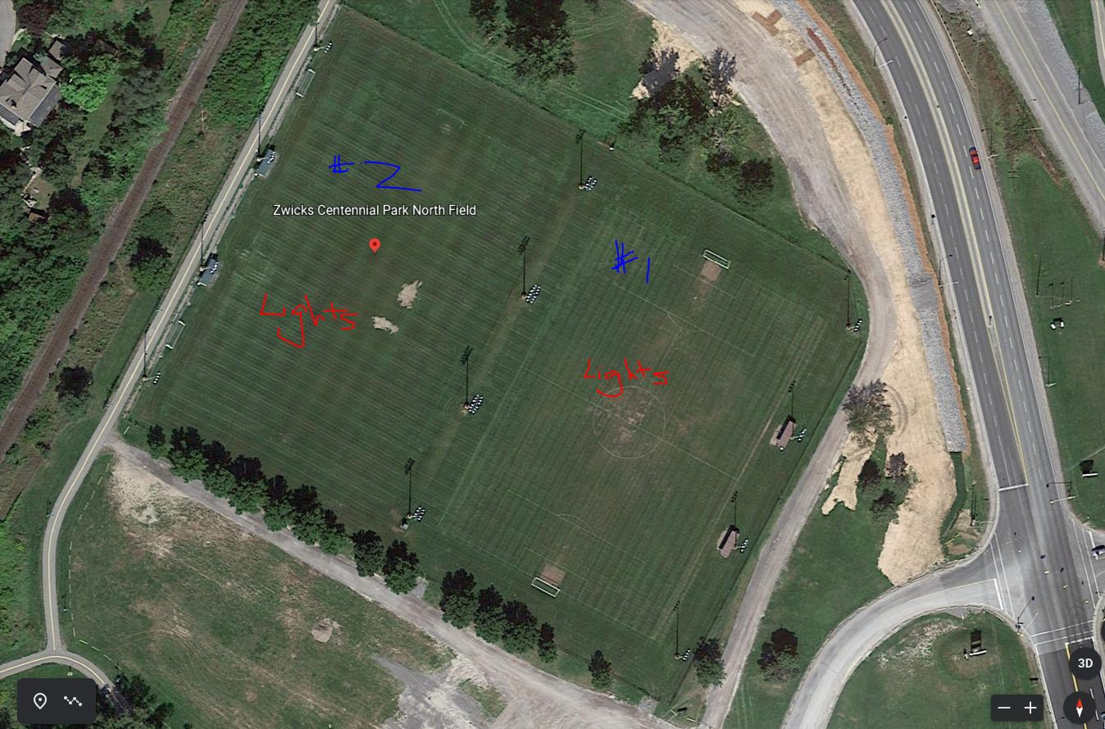
Field F – Zwicks#1
Field G – Zwicks#2

